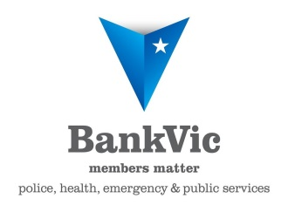
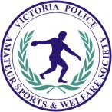

Most Outstanding Police Recreation,
Social Or Other Achievement of the Year
Proudly sponsored by BankVic
Nominations close 13 July, 2018
NOMINATION CRITERIA & GUIDELINES

This award will be given annually. It will be given to a Victoria Police club or Member Association who has shown both a sustained educational and social skill development of its members, and the implementation of strategies to assist their communities in any of the following areas of concern;
- family violence,
- youth and community engagement,
- supporting the disadvantaged and/or disabled,
- promoting social harmony/inclusivity,
- honouring fallen comrades/supporting their families, or
- other outstanding achievement.

The nominee must be;
- A Club affiliated with the Victoria Police Amateur Sports and Welfare Society (VPASWS)

Assessment period:
- 1 July, 2017 to 30 June, 2018

General Information:
(a) Nominations on the official form with any supporting documentation must be in the hands of the Executive Officer by 13 July 2018.
(b) One nomination only per Member Association or Club
(c) The Selection Panel shall be the Executive Committee of the VPASWS
(d) Although this award brings into focus the more recreation/welfare oriented clubs such as the Angling clubs; the Four Wheel Drive club; Friends of the Library; Historical Society; the ‘Law Enforcement Torch Run’; Past and Present Women Police Association; Police Scouters; the Victoria Police Muslim Association, and the United Nations Police club, other clubs affiliated with the Society are also eligible.
(e) Those clubs that have been most active in the implementation of their outstanding achievement e.g. building a sustainable partnership with a community/disadvantaged group, regardless of whether or not they have implemented strategies for an annual VPAS&WS ‘Common Theme’, will be provided equal consideration. However, the assessment of the nominations will be made only on the information supplied with the Nomination Form.
(f) The awards will be presented at an awards dinner to be held as follows:
Victoria Police Sports Awards Dinner
'Celebrity Room', Moonee Valley Racing Club
26 September, 2018
At 1930 hours
Nominee Details

Name of Club:
Name of Coach/Manager:
Work Address:
Phone (w): (h/m):
Email:

Recreation, Social or Other Highlight (Please complete all sections of this form)

Name of event: Date:
Strategies for the event:
Outcomes achieved for members of your club:
Outcomes achieved for the local community and for our society in general:
Other factors contributing to the increased understanding of your club members to recreation or social needs of the local community:
A safer Victoria (Please describe how your clubs efforts have contributed to the Victoria Police’s vision for a safer Victoria.):

General Information

Is there any film recording of the nominated event available? (If yes, what type of format? i.e. DVD)
Are photographs of the nominated performance available? (If yes, how can they be obtained?)

Nominated By

Association/Sporting/Recreation/Social Club:
Name:
Position Held:
Work Address:
Phone (w): (h/m):
Email:

Closing Date for Nominations - 13 July 2018
Please forward completed nominations* via email or hard copy to:

Executive Officer
Victoria Police Amateur Sports & Welfare Society Inc.
C/- Physical Training Unit
Victoria Police Academy
View Mount Road
Glen Waverley, Vic, 3150
DX: 211825
Telephone: (03) 95669477
Email: victor.hawking@police.vic.gov.au

*Form is supplied as a guide only. Please attach any further information that may assist in

